KARNATAKA VETERINARY ANIMAL AND FISHERIES SCIENCES UNIVERSITY, BIDAR
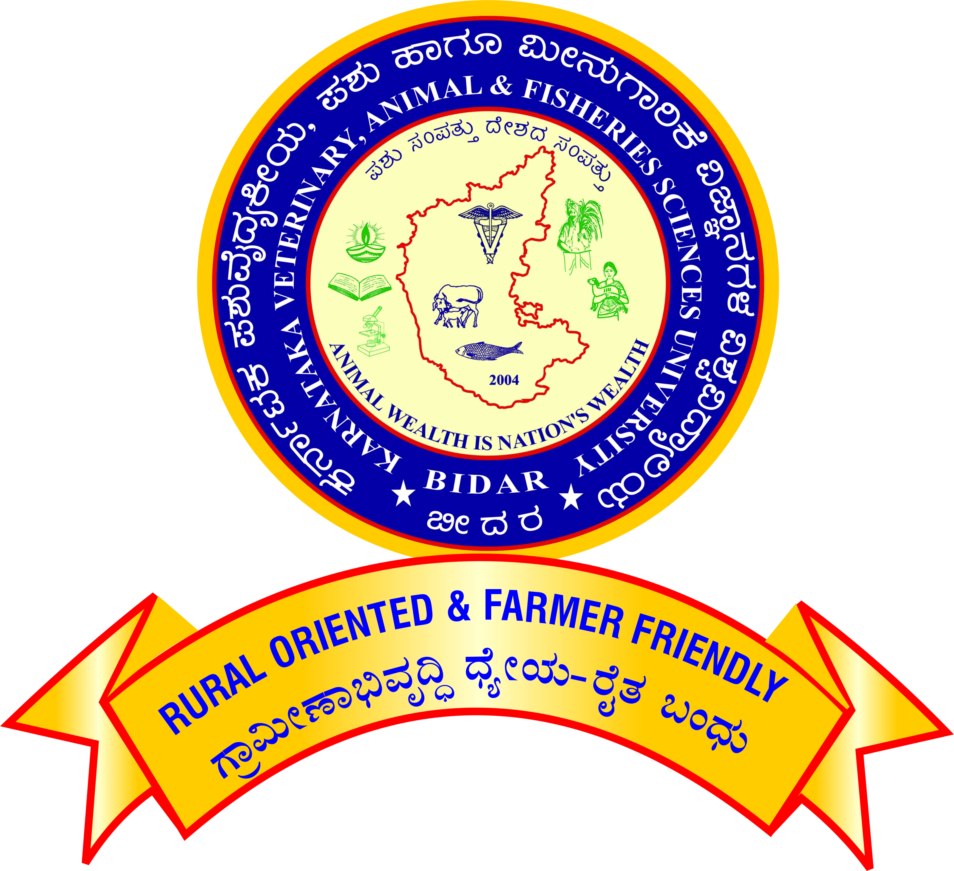

APPLICATION FOR PROMOTION OF TEACHERS UNDER CAREER ADVANCEMENT SCHEME – 2016

For promotion from Assistant Professor (Academic Level 11) to Assistant Professor (Academic Level 12)

[Note: All the claims shall be supported by relevant letters/certificates issued by concerned dean/controlling officer]
Affix self-attested photo
1. Name :

2. Designation and Address :

3. Name of the Department/ :

Section/Unit/Scheme

4. Date of Birth :

5. Academic Qualification :

Degree / Diploma | Discipline/  Subject | University/ Board | Month/  Year of passing | Marks/ OGPA  obtained | Remarks

6. Date on which Ph.D. degree Completed :

7.
- Date of joining duty at KVAFSU, BIDAR as Assistant Professor in the Academic Level 10/AGP 6000 | :
- Date of joining duty at KVAFSU, BIDAR as Assistant Professor in the Academic Level 11/AGP 7000 | :

8. Date of completion of 5 years’ service :
in the cadre of Assistant Professor
(Academic Level 11/AGP 7000)

9. Employment record:
- Service within the university

Place of work with full address | Designation / Post held | Scale of Pay | Period |  | Nature of duties
 |  |  | From | To
b. Service outside the university

Place of work with full address | Designation / Post held | Scale of Pay | Period |  | Nature of duties
 |  |  | From | To

10. Eligibility for Promotion
- Have you done any two of the following in the last five years of Academic Level 11/AGP 7000?
- Completed a course/ programme from amongst the categories of Refresher courses/ Research methodology course/ workshops/conference/symposium/ syllabus up-gradation workshop/ Teaching-Learning-Evaluation/ Technology Programmes/Faculty Development Programmes of at least ten days duration (or completed two courses of at least five days duration in lieu of one ten days programme
OR
- Completed one MOOCs course in the relevant subject (with e-certification);
OR
- Contribution towards the development of e-content in 4-quadrant (at least one quadrant) minimum of 10 modules of a course/contribution towards the development of at least 10 modules of MOOCs course/ contribution towards conduct of a MOOCs course during the period of assessment?
Yes/No
If yes furnish details as follows and enclose proof
Sl No | Title of training Program | Duration with dates | Organized by

- Have you published three research publication in the in the peer- reviewed journals or ICAR / UGC-listed journals during assessment period? Yes/No.

If yes furnish details as follows and enclose copy of the same
Sr. No. | Authors | Title of the publication | Year | Volume and page numbers

11. Details of Work Performance:

Areas in which the scientist/teacher made some mark including the specific Achievements in teaching/ research/Extension/corporate activities (administration and management) during the assessment period.

A) Teaching:
ai. Courses taught
i) Bachelor level:

Course title | Year & Class | Course No. | Cr.Hrs. | Semester | Independently or Jointly with
Academic Year:

ii) Master level:

Course title | Year & Class | Course No. | Cr.hr | Semester | Independently or Jointly with
Academic Year:

iii) Ph.D. level:

Course title | Year & Class | Course No. | Cr.hr | Semester | Independently or Jointly with
Academic Year:

iv). Diploma courses:

Course title | Year & Class | Course No. | Cr.hr | Semester | Independently or Jointly with
Academic Year:

aii) Experiential Learning Course, HOT/RAWE/Industrial training/ Entrepreneurship:

b). Guidance to PG students as Chairman of the Advisory Committee
- Completed Masters Students :
- Completed Ph. D. Students :

c). Guidance to PG students as Member of the Advisory Committee
- Completed Masters Students :
- Completed Ph. D. Students :

d). Teaching Aids developed (manuals/ :
laboratory manuals, READY manuals/
Internship/Industrial training manuals).

B). Research:
- Externally funded projects

Sl.  No | Title | Funding agency | Budget | Year of Start | Year of completed | As PI /Co-PI

Note: The Project shall be completed/in operation and Funds must be released.

- Patents / varieties / prototypes / technologies developed / breeder quality seeds production
i) As PI :

ii) As Co-PI :

- Monitoring of the research/extension projects such as RKVY and other GoI/GoK Projects (Other than Externally Funded Projects).

Sl.  No | Title | Funding agency | Budget | Year of Start | Year of completed | Involved as

- Guiding project works of 1 month and above :

- i) Head/Farm Superintendent in Research & Information Centers/Vaccine/Antigen production units/Disease investigation Section. :

ii) Working in the research & Information :
Centers as Scientist/Teacher

- Internal Revenue Generation (Applicable only for LRIC/FRIC/RRDL to be certified by Director of Research) :
C) Extension:

- Transfer of technologies (farm trails/ :
Field days/ Krishi Melas/ Demonstrations/
Exhibition/ Discussion meeting/ on-farm
Testing/ on campus official consultancy conducted

- Training programme organized:
- Duration: upto 1 week

i) As Coordinator :
ii) As Associate Coordinator :

Sl No | Title | Duration | Place and Date | Organized by | Coordinator/Associate Coordinator

- Duration: more than one week:

i) As Coordinator :
ii) As Associate Coordinator :

Sl No | Title | Duration | Place and Date | Organized by | Coordinator/Associate Coordinator

- As Resource Person in the training Programme :
Number of Lectures:
Sl No | Place and Date | Type of Event | Title of Training | Topic Discussed | Organized by

- Official Diagnostic visit to farmer’sfields:
/On-farm/ Units/Radio/TV talk/Expert
Service/ Consulting/Visitors extension

- Feedback to research/ Contribution to Package of practices

- Clinics/ Diagnostic/ Farm Work/ Head:
of EEC/ (Other than teaching)

Published work during the assessment period
- Research Publications:

Sl  No | Name of Author(s)  in order | Year | Title of the paper | Name of the journal  (Vol. No., issue no & page no) | NAAS Rating
- Professional Book published/Edited (Minimum of 64 pages-Only with ISBN No.)

- Recognized publishers
- Chapters in standard books
- Research / Extension bulletin

- Research note /communication in a journal / Presentation or abstract in symposium seminar / workshop / training manual /popular article / leaflet proceedings of the workshop

III. Awards/Peer Recognition (During the assessment period)

- Awards from recognized International organizations like FAO, OIE/WoAH, WHO, IDF etc :
- National awards by Govt. Institutions :
- Recognized State awards / University awards :
- Professional society award :
- Other awards by registered organization :
- Peer Recognition (Special assignments (International organizations, overseas and special national assignments / consultancies) :

IV. Corporate Responsibilities / Other activities during the assessment period:

V. Outstation Service Details :

Sr No. | Post held | Place of Work | Period of service |  | Place/City Class (A/B/C)
 |  |  | From | To

VI. Details of working in newly established colleges (W.e.f. 11-08-2018)

Sr No. | Post held | Place of Work | Period of service
 |  |  | From | To

- Indicate three best contributions made (research /teaching / Extension/corporate activities (Administration and management) during the assessment period.

- Any other significant achievement during the assessment period
(with documents)

Signature

Verified that the information provided by the scientist/teacher is correct.

Signature of the  Head of the Department | Signature of the  Controlling Officer

